Quiz Manager Review

The project has been fully tested manually and works as expected. It meets all of the requirements set out in the initial specification as well as further requirements regarding correct answers that I assumed. From that perspective the project has been highly successful.

There are several areas where the project could improve, however. Perhaps the most obvious is the omission of the pagination feature on the list page. I ran out of time before I was able to create this component. For demonstration purposes this is of little consequence but this would pose an issue if there were hundreds of quizzes in the database.

The backend project has some, but not full, unit test coverage. Given more time I would have liked to have expanded this coverage. I also did not have time to write any unit tests for the frontend nor any end-to-end test scripts. If this project were to go live, I would want to gain much higher unit test coverage and write the end-to-end test scripts.

I also made a couple of mistakes in the design of the GenericRepository in the backend project.

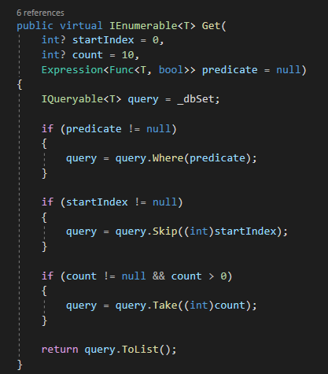

This screenshot shows the Get method on the repository. The first two parameters are nullable. My idea here was that the method could be called using only the third parameter. This would have been better achieved by writing an overload of the function instead of making the first two parameters nullable.

Secondly, the logic surrounding the start count and index is business logic. That should have been moved to the Core tier.

Aside from the considerations above, I am satisfied with the outcome from the project. I have not written a user guide for the application because I think it is very simple to use. I would not consider this a limitation or area for improvement; I believe the interface is intuitive enough to justify omitting a user guide.